Maaret Koskinen

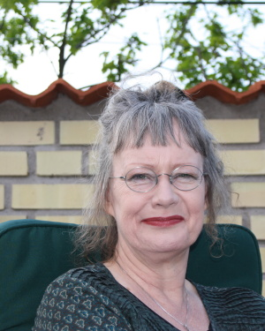

Professor and PhD in Cinema Studies. Maaret Koskinen, Professor at the Department of Media Studies, has been Visiting Professor at various universities (e.g. Fulbright Fellow at Cornell), and her publications on authorship, intermediality, and popular film have appeared in a number of national and international journals. Koskinen was the first scholar given access to Swedish writer and film/theatre director Ingmar Bergman’s private papers during the last years of his life, and organized the first international Bergman symposium in Stockholm in 2005. She was also appointed Honorary ’Ingmar Bergman Professor’ by Stockholm University and the Bergman Foundation jointly in 2009.
Aside from research and teaching, Koskinen has served in a number of public positions. She was Member (appointed by the Ministry of Culture) of The Swedish Broadcasting Commission between 2003-2006, and Member of the Board of the Swedish Film Academy for two consecutive terms. She has also been Member (appointed by the Ministry of Law) of the Stockholm Court of Appeal in cases re. films ratings, and in 2014 re-elected as Member if the Board of the Swedish Film Institute (2011-2013, 2014-2016). She served as the Chair of The Swedish Association of Film Critics, and in a number of film juries (including Guldbaggen, the Swedish counterpart to the Oscars), and has written on film in Sweden’s largest national daily Dagens Nyheter.

Koskinen has authored several books on Bergman’s work in film, theatre, and literature from various theoretical perspectives. Her PhD dissertation in 1993, called (in translation) Plays and Mirrors. The Cinematic Aesthetics of Ingmar Bergman, was followed by ’Allting föreställer, ingenting är’. Filmen och teatern - en tvärestetisk studie (2001), which deals with intermedial relations between Bergman’s films and his work in the theatre. In 2002 she published I begynnelsen var ordet. Ingmar Bergman och hans tidiga författarskap (also translated into Finnish as Alussa oli sana - Nuori Ingmar Bergman, LIKE 2003), which was nominated for the Swedish literary ’August’ award. It explores unpublished materials in Bergman’s private archive, focusing on his work as author of literary fiction. Her next book too (with Mats Rohdin) explored unpublished diaries and scripts in the archive, and focuses the writing and making of Bergman’s last feature, Fanny and Alexander (2005). Her books in English include (as editor) Ingmar Bergman Revisited. Cinema, Performance and the Arts (Wallflower Press, 2008), with contributions by amongst others Janet Staiger, Thomas Elsaesser, and Paisley Livingston; and Ingmar Bergman’s THE SILENCE. Pictures in the Typewriter, Writings on the Screen (University of Washington Press, 2010). Other publications on Bergman include:
“Ingmar Bergman, the biographical legend and the intermedialities of memory”, Journal of Aesthetics & Culture, vol. 2, 2010: 1-11. doi: 10.3402/jac.v2i0.5862
“Le Cinéaste comme Écrivain ou l’Écrivain comme Cinéaste?”, 293-315. I Jean-Louis Leurat, red, Cinéma & literature. Le grand jeu. Paris: De l’incidence éditeur, 2010 (ISBN 978-2-918193-05-0).
"Foreword", 1-7. In John Orr, Ingmar Bergman: The Demons of Modernity: Ingmar Bergman and European Cinema. New York: Berghahn, 2014.
"Multiple adaptation processes: The case of Alexander Ahndoril’s The Director and its predecessors in feature film, television documentary and popular print media", Journal of Scandinavian Cinema, 5: 1, pp. 35–47, 2015, doi: 10.1386/jsca.5.1.35_1

